JWTD Lab Assignment-3

211047022

Athul u c

1. Index.html

<html>

<head>

<title>Java lab3</title>

</head>

<body>

<h1>Welcome!!! This is the sample web page for java servlet example</h1>

<form action="lab3_assn" method="post">

usn: <input type="number" name="usnn"/><br> <br>

Name: <input type="text" name="namee" /><br> <br>

Marks: <input type="Number" name="markss" placeholder="Insert your marks1 "/> <br> <br>

<input type="submit"/>

</form>

</body>

</html>

1. lab3_assn.java

import java.io.*;

import javax.servlet.*;

import javax.servlet.http.*;

public class lab3_assn extends HttpServlet {

//@Override

protected void doPost(HttpServletRequest request, HttpServletResponse response) throws IOException, ServletException {

String usn = request.getParameter("usnn");

String Name = request.getParameter("namee");

String Marks = request.getParameter("markss");

PrintWriter out = response.getWriter();

response.setContentType("text/html");

out.println("<h1> Welcome " + usn+ "</h1>");

out.println("<br><br>");

out.println("<h2> Your name and marks is </h2>");

out.println(Name);

out.println(Marks);

}

}

1. Web.xml

<?xml version="1.0" encoding="UTF-8"?>

<web-app

xmlns="https://jakarta.ee/xml/ns/jakartaee"

xmlns:xsi="http://www.w3.org/2001/XMLSchema-instance"

xsi:schemaLocation="https://jakarta.ee/xml/ns/jakartaee https://jakarta.ee/xml/ns/jakartaee/web-app_5_0.xsd"

version="5.0"

>

<servlet>

<servlet-name>lab3_assn</servlet-name>

<servlet-class>lab3_assn</servlet-class>

</servlet>

<servlet-mapping>

<servlet-name>lab3_assn</servlet-name>

<url-pattern>/lab3_assn</url-pattern>

</servlet-mapping>

</web-app>

Screenshot 1

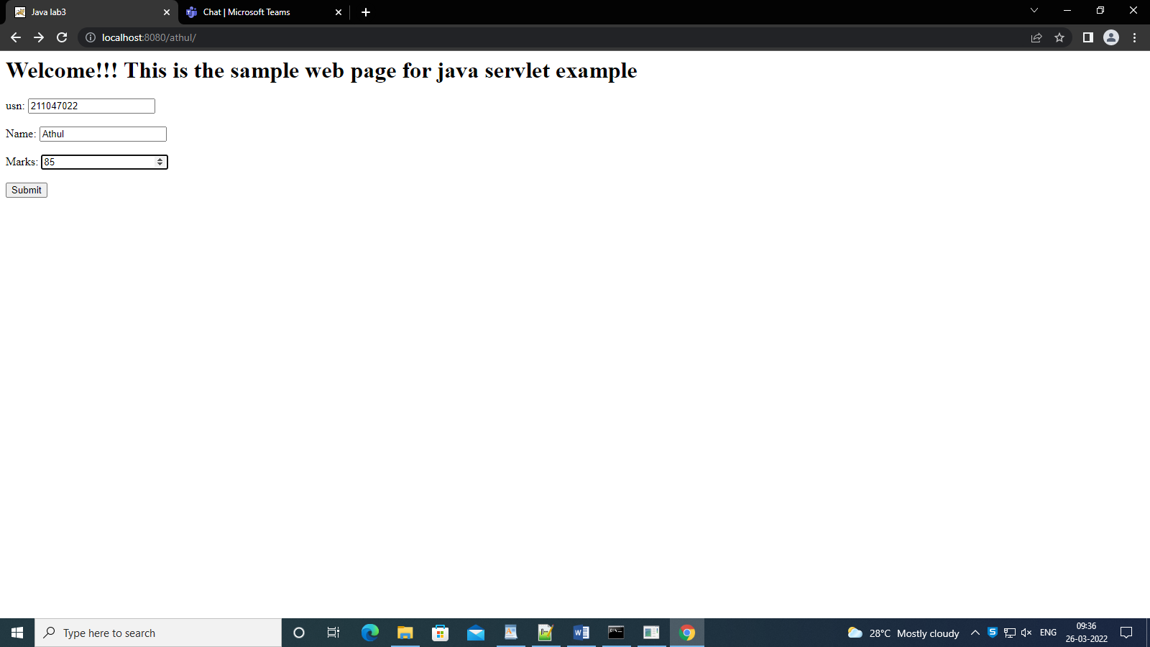

Screenshot 2

